Remember – we only add the numerators (top numbers). We never add the denominators (bottom numbers). This means the Denominators MUST be the same.
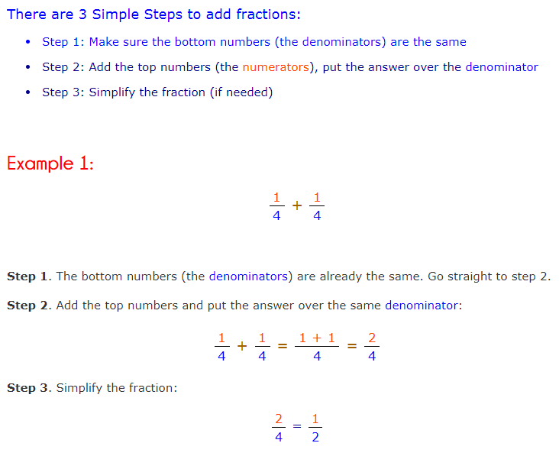

Remember - If the denominators are different, we need to change them so they are the same before we can add.
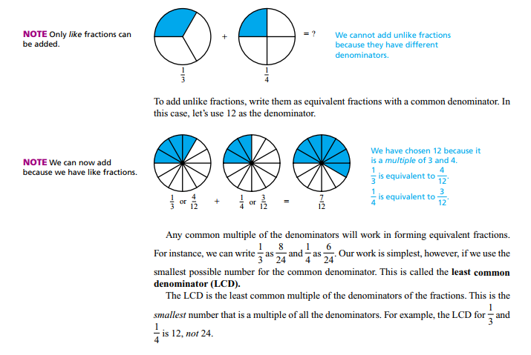

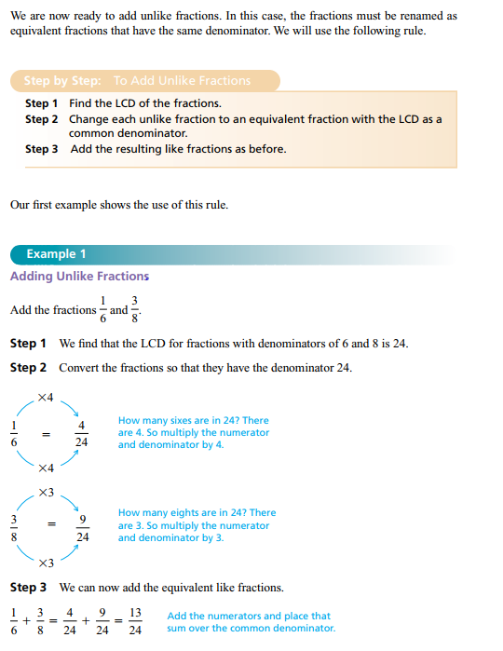

Remember – If you are subtracting you use the same method but subtract on the final step.

If you need to add/subtract a mixed number – change them both to a improper fraction first before you add them. Then simplify them back afterwards. Here is an example of how to change a mixed number
